SIMATS ENGINEERING
ASSESSMENT TOOL 3

COURSE NAME: MLA03
COURSE CODE: Reinforcement learning

COURSE OUTCOME COVERED

CO1: Analyze reinforcement learning frameworks and Markov Decision Process concepts to model decision-making problems.( BL2, BL3)

Assessment Tool Weightage: 50%

Dr G.A. SENTHIL

QUESTIONS: 10 Total Marks:50

Annexure A

Constraint - Based Problem-Solving Duration: 2Hrs
- Develop a Python-based Reinforcement Learning model using the OpenAI Gym environment to solve a Grid World navigation problem where the agent must reach the goal while avoiding obstacles. Explain how the state space, action space, reward function, and constraints are defined.
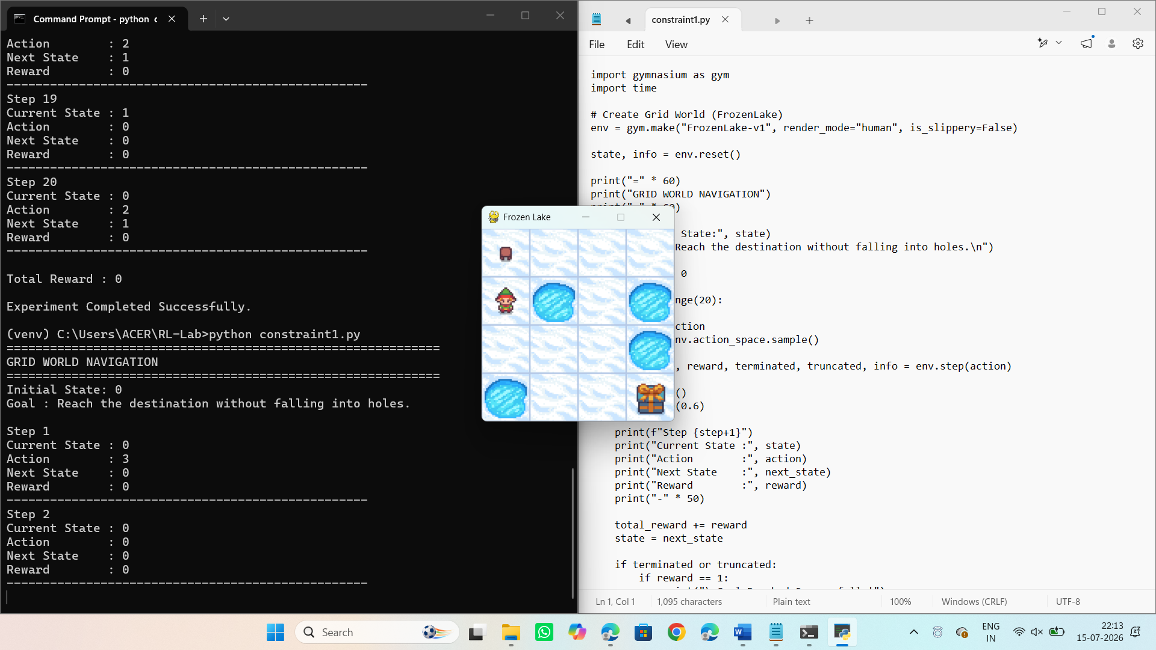
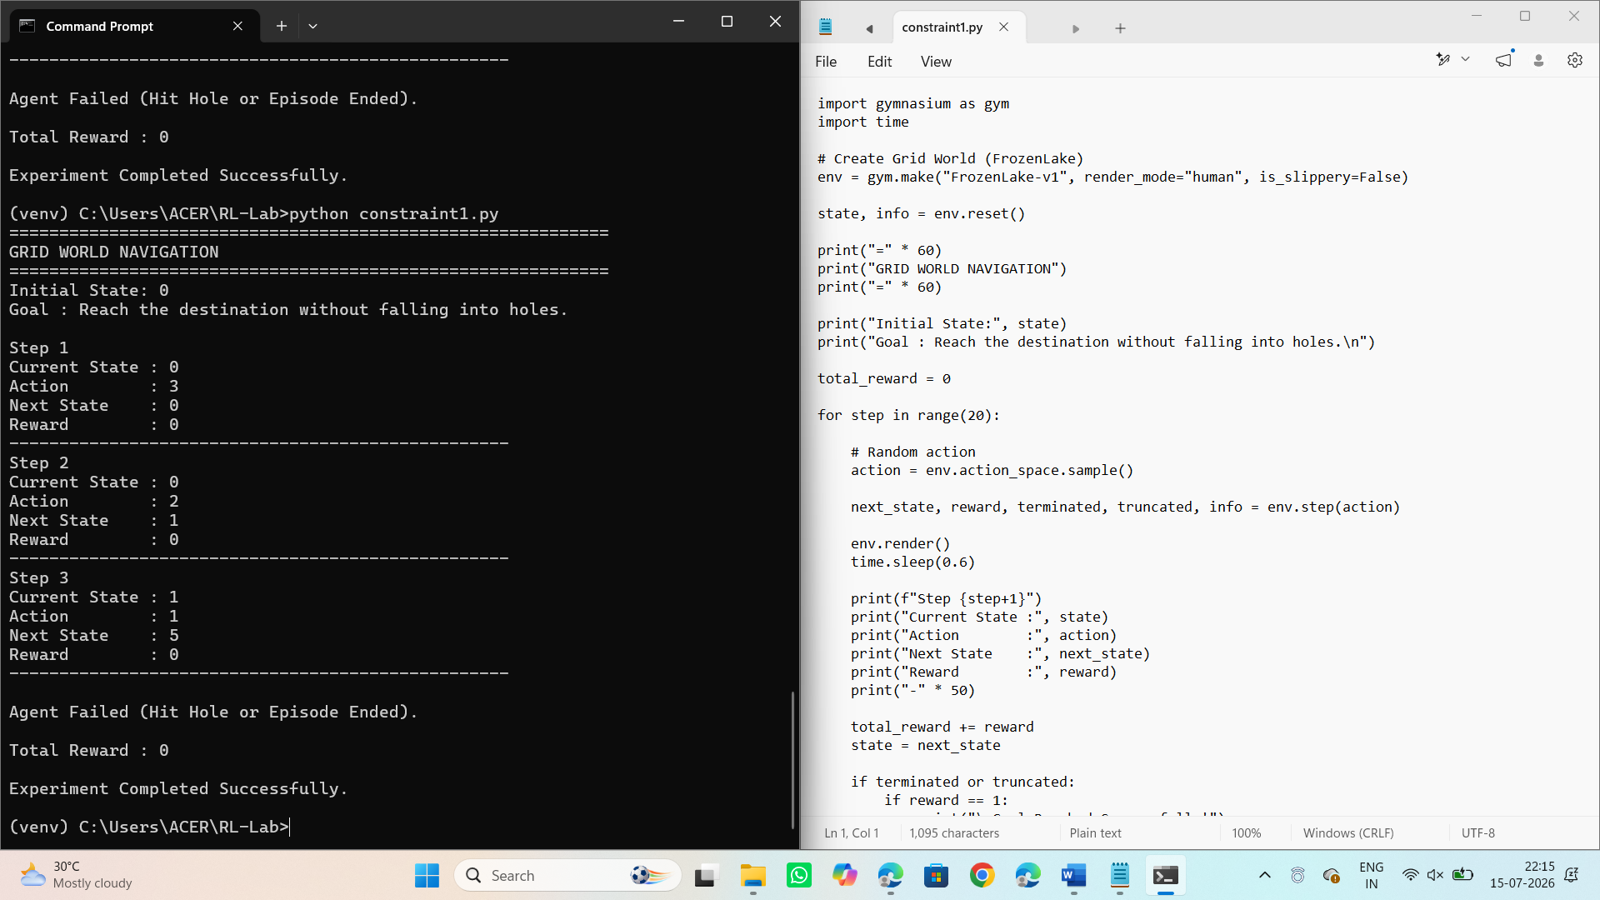

- Implement an ε-greedy Multi-Armed Bandit algorithm in Python to maximize rewards under a limited budget of 500 trials. Compare the effect of different ε values (0.1, 0.3, and 0.5) on exploration, exploitation, and constraint satisfaction.
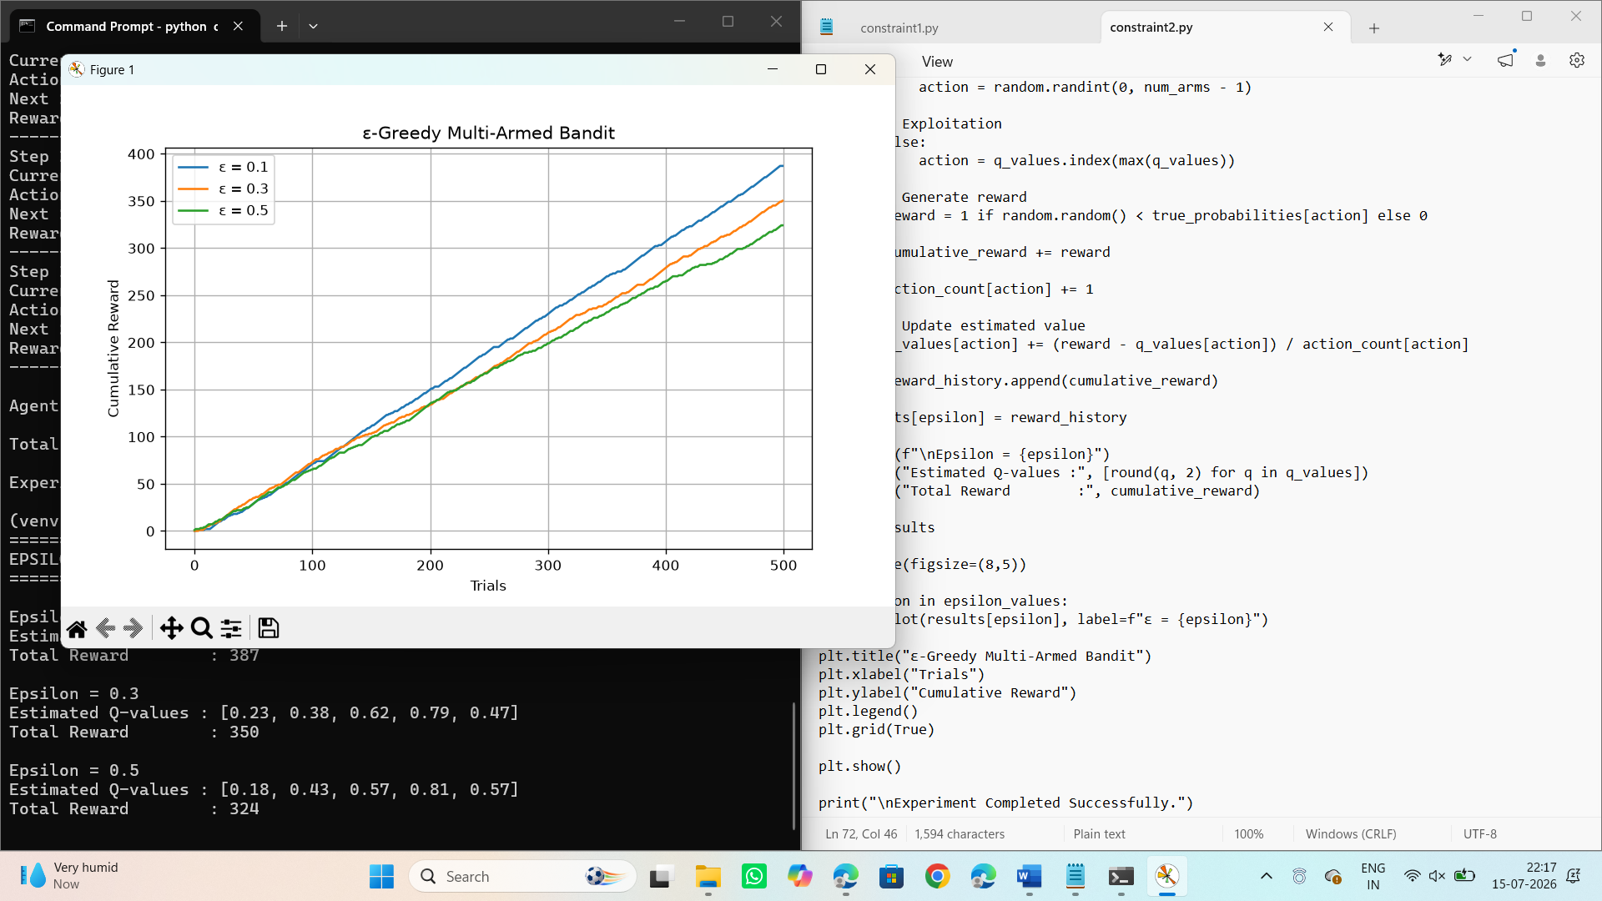
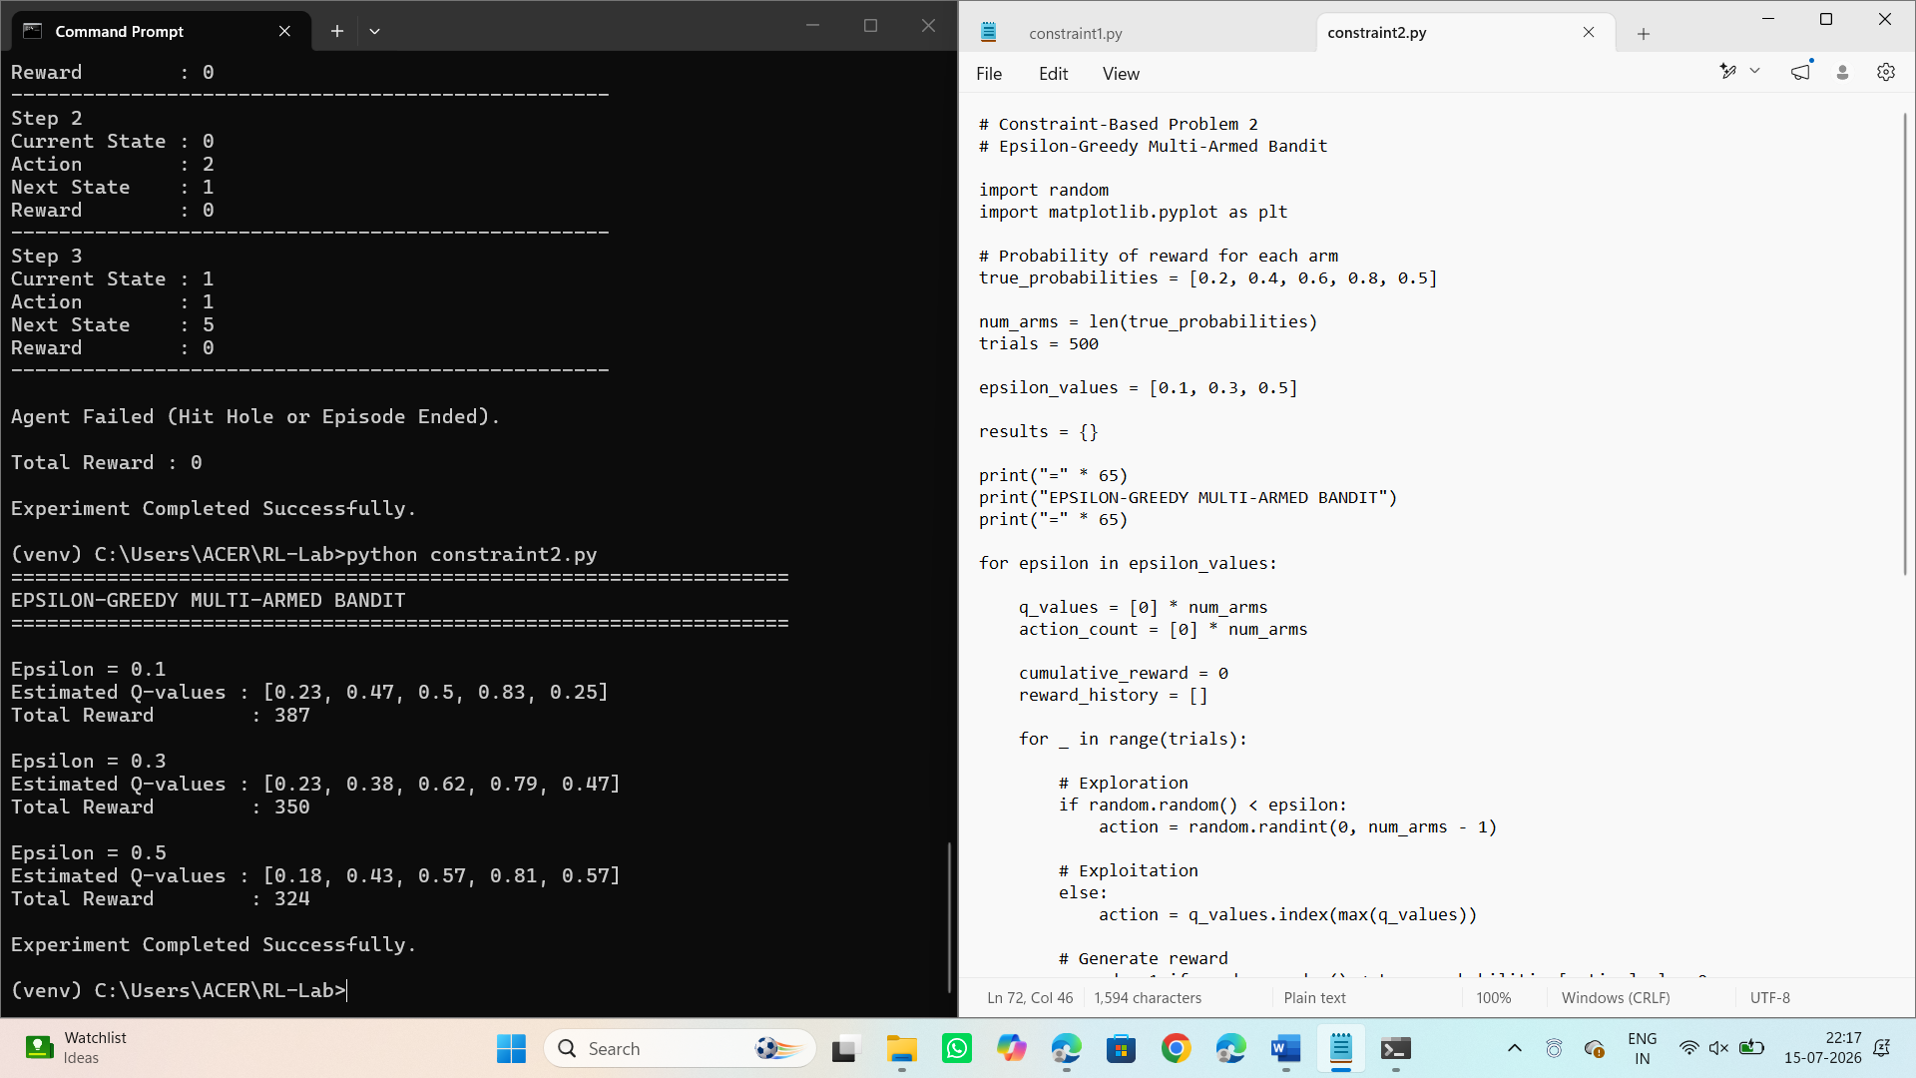
- Design a Markov Decision Process (MDP) for an autonomous robot that must reach a destination while minimizing energy consumption. Define the states, actions, transition probabilities, rewards, and energy constraints.
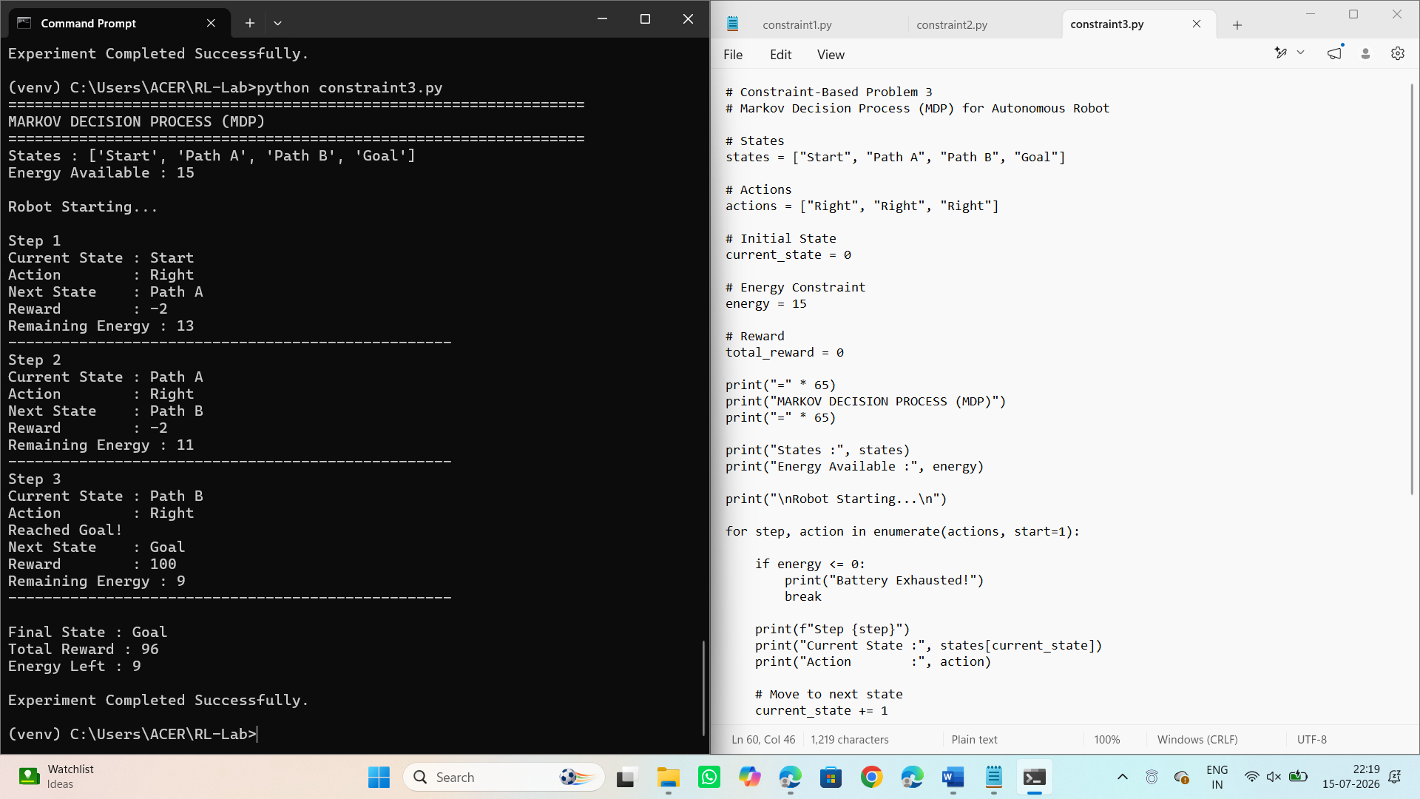

- Using Python and TensorFlow/Keras, implement a value iteration algorithm to determine the optimal policy for a constrained grid environment where certain states are restricted. Explain how Bellman equations are used to obtain the optimal policy.
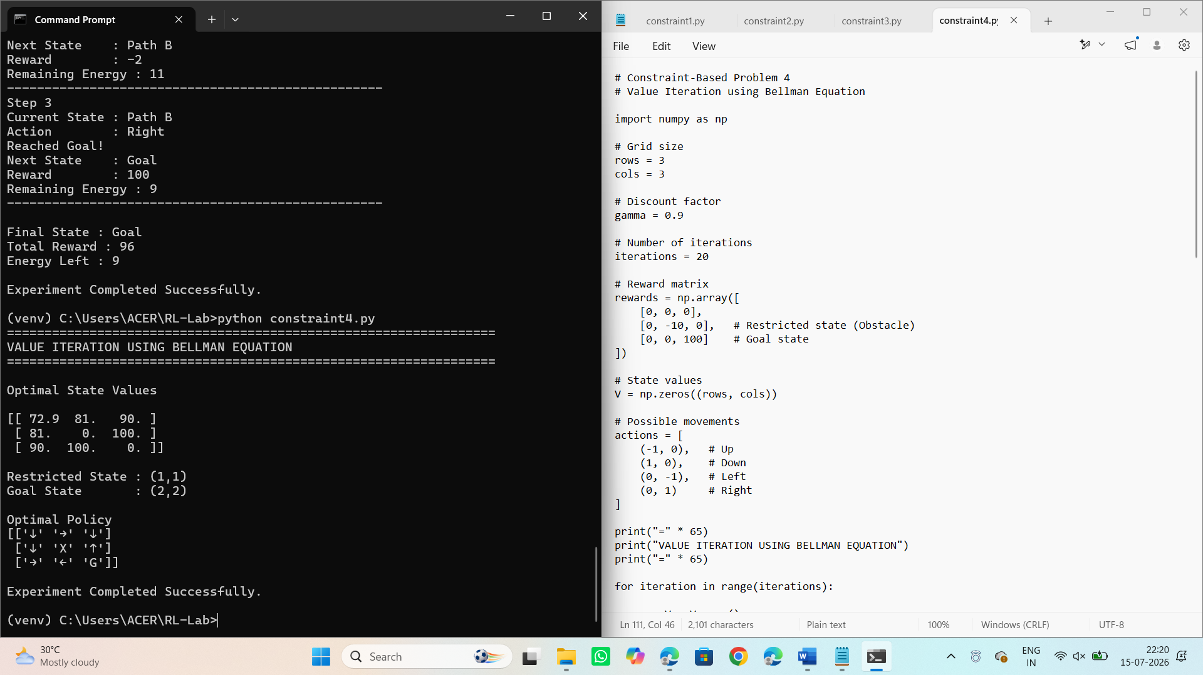

- Analyse an experimental comparison between random action selection and ε-greedy action selection in a Multi-Armed Bandit problem under a fixed time constraint. Record cumulative rewards and explain which strategy provides better performance.
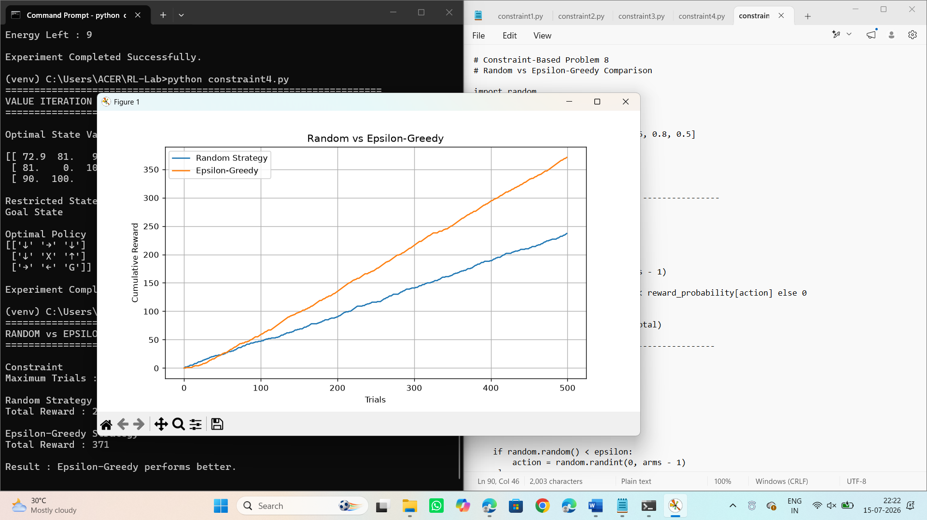
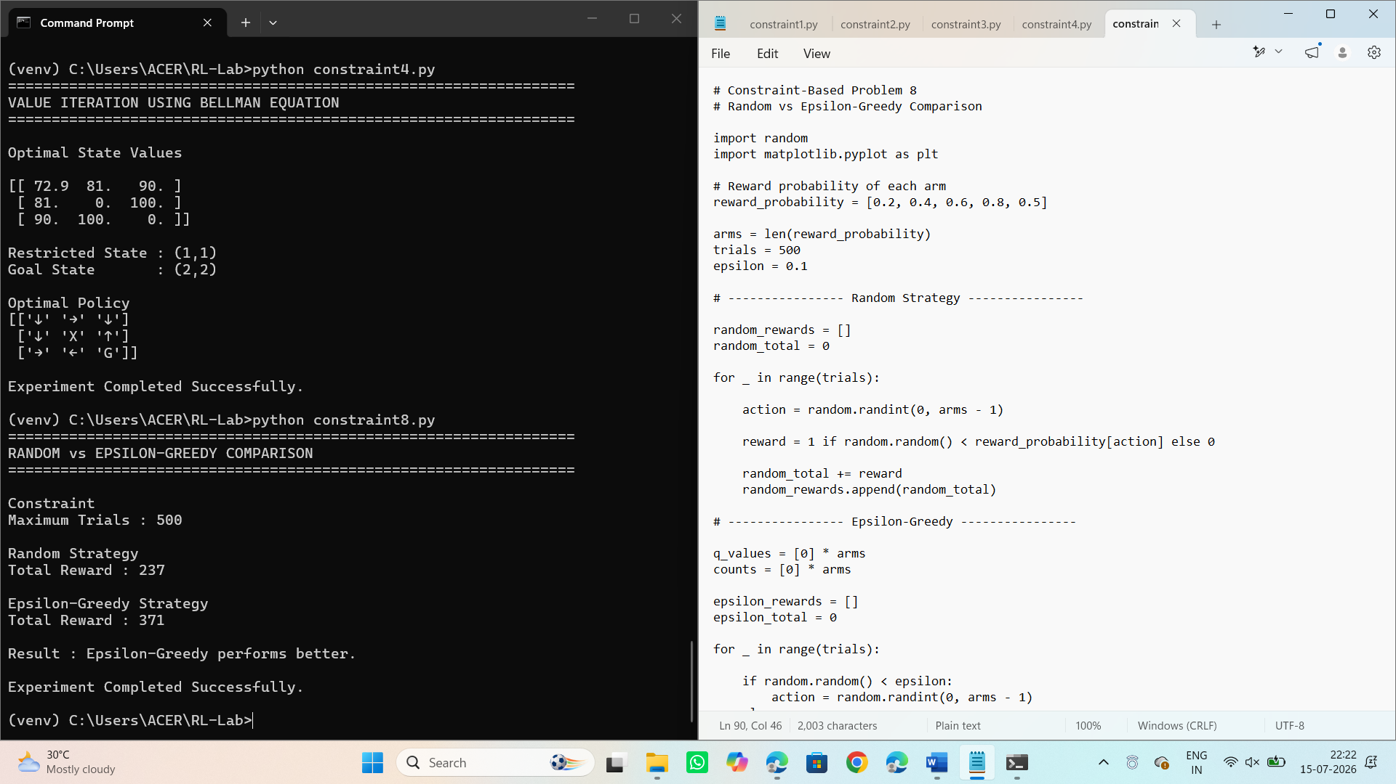

Code of Conduct:

I _S.Sirivally / 192472371_ (Name / Reg No) certify that this submission is my original work and that I have adhered to the guidelines specified for this assessment.
I understand that any violation of academic integrity rules will result in disciplinary action.

Signature of the student:

RUBRICS FOR CALCULATION

Criteria | Weightage | Level 4 (Exemplary) | Level 3 (Proficient) | Level 2 (Developing) | Level 1 (Beginning)
Problem Understanding | 25% | Clearly defines the problem and identifies all relevant constraints accurately | Identifies most constraints with minor gaps | Partial understanding; misses key constraints | Fails to identify constraints correctly
Constraint Analysis | 25% | Analyzes constraints effectively and prioritizes them logically | Provides reasonable analysis with some prioritization | Limited analysis; weak prioritization | No meaningful analysis or prioritization
Solution Development | 25% | Develops optimal and feasible solutions satisfying all constraints | Develops workable solutions with minor limitations | Solutions partially satisfy constraints | Solutions do not meet constraints
Application of Concepts | 15% | Effectively applies appropriate concepts, methods, or tools | Applies concepts with minor errors | Limited application; requires guidance | Unable to apply relevant concepts
Justification | 10% | Provides strong justification for decisions with logical reasoning | Provides justification with some clarity | Weak or unclear justification | No justification provided

